**Fuzzy and Probabilistic Evaluation of the Human Health Risk of the Shallow and Deep Groundwater in Baicheng City, Northeastern China**

Xinkang Wanga,b,c,d, Changlai Xiaoa,b,c,d, Weifei Yanga,b,c,d, Jinwei Chenga,b,c,d,

Xiujuan Lianga,b,c,d,*, Linzuo Zhanga,b,c,d, Jiang Zhanga,b,c,d

1. Key Laboratory of Groundwater Resources and Environment (Jilin University), Ministry of Education, Changchun 130021, China
2. Jilin Provincial Key Laboratory of Water Resources and Environment, Jilin University, Changchun 130021, China
3. College of New Energy and Environment, Jilin University, Changchun 130021, China
4. National-Local Joint Engineering Laboratory of In-situ Conversion, Drilling and Exploitation Technology for Oil Shale, Changchun 130021, China

Corresponding authors: Xiujuan Liang([xjliang@jlu.edu.cn](mailto:xjliang@jlu.edu.cn))

**Abstract**

Groundwater acts as a vital water-supply source for drinking purposes worldwide. However, the oral ingestion of potable groundwater with high toxic contaminant contents (such as arsenic, fluorine and nitrate etc.) poses adverse impacts on human health. Thus, there is a need to assess the potential health risks of the potable groundwater in Baicheng City. In this study, human health risk evaluation(HHRE) of the direct drinking shallow and deep groundwater by two age groups(children and adults) in the different districts of Baicheng City was conducted using a Triangular Fuzzy Figure (TFF) model (a fuzzy mathematical method) and a TFF-Monte Carlo model (a stochastic mathematical method). Three potential contaminants were identified: the arsenic(carcinogenic and non-carcinogenic risk) and fluorine(non-carcinogenic risk) contamination mainly caused by pro-geological processes and the nitrate(non-carcinogenic hazard) pollution mainly caused by human inputs. The TFF model and TFF-Monte Carlo model demonstrated that the total non-carcinogenic(*Rn*) and carcinogenic(*Rc*) risks for residents in Baicheng City had high probabilities of exceeding the safety value but regional discrepancies were evident. Compared with other counties, the residents in Tongyu County were confronted with the severest health risks(*Rn* and *Rc* values were the largest) due to the serious arsenic and fluorine pollution in both the shallow and deep groundwater. What’s more, local children are more susceptible to the cumulative influences of the potential pollutants due to the lager values of *Rc* and *Rn* caused by the parameter discrepancies than adults. Sensitivity analysis demonstrated that regional differences existed in terms of the controlling factors influencing *Rn* values and the priority should be to lower the concentrations of arsenic from the shallow and deep groundwater in TY and DA to lower the cancerous and non-cancerous risks to children and adults. This research is conducive to implementing corresponding and effective regional groundwater regulation and remediation strategies to Baicheng City.

**Key Words:** Potable groundwater; TFF model; TFF-Monte Carlo model;Health risk evaluation; Arsenic and fluorine contamination; Nitrate contamination

**Highlights:**

1. TFF and TFF-Monte Carlo models were used for a human health risk evaluation.
2. Arsenic, fluorine, and nitrate were the potential contaminants in Baicheng City.
3. Arsenic contents contributed the most to the results of HHRE.
4. Children tended to be more susceptible to toxic substances, compared with adults.
5. Residents in Tongyu County faced the severest health risks.

**Graphical Abstract：**

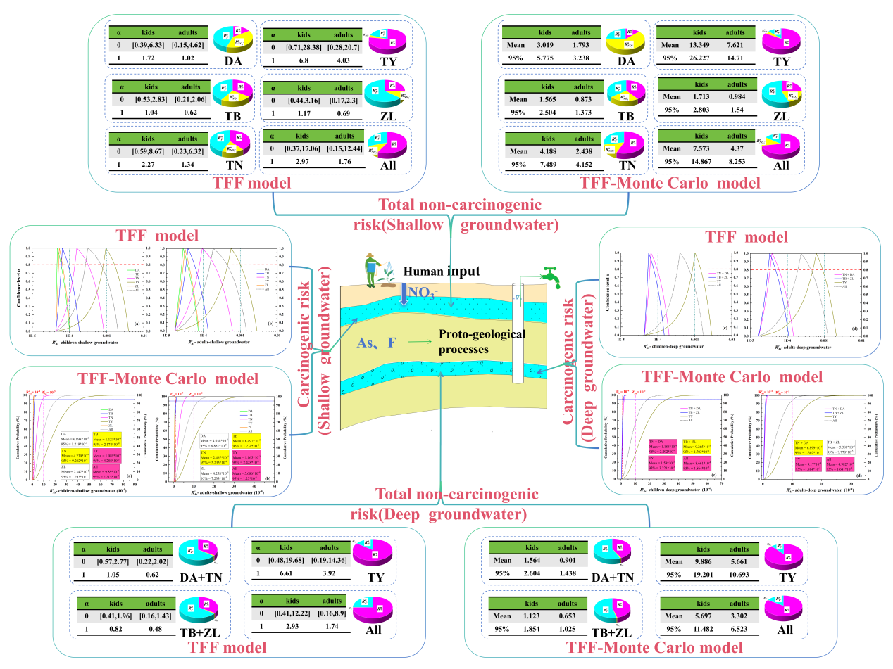

1. **Introduction**

Groundwater is considered as an invaluable clean and fresh water resource(Zainab et al., 2020), which comprises a large proportion of water use for daily domestic needs, agricultural irrigation, drinking water supply, industrial production aspects. Additionally, it is sometimes the sole choose of the potable water without any treatment in some developing and remote zones of the world(Wu et al., 2021). However, potable groundwater with high contents of pollutants like arsenic(Gholami & Sahour, 2023; Rodríguez-Lado et al., 2013; Ruzicic et al., 2023; Smith et al., 2000), fluorine(Li et al., 2019; Singh et al., 2018), nitrate(Adimalla & Qian, 2019) poses greatly adverse effects to the health, survival and longevity of the local residents in the areas where groundwater accounts for huge contributions for the drinking water supply, especially the water-scarce dry and semi-arid ones(Rahmati et al., 2016).

The presence of the abnormally high toxic material contents in groundwater is the outcome of the complex natural factors (water-rock interactions, and evaporation etc.) and anthropogenic inputs(Wang et al., 2023). As a trace nonmetallic element, drinking groundwater with excessive arsenic (>10 ug/L) greatly increases the possibility of getting cancer (lung, liver, kidney and bladder) and chronic arsenic poisoning(Jadhav et al., 2015). As a double-sided substance, a low intake of F- will lead to dental caries and bony osteoporosis, whereas an excess of F- will trigger fluorosis(He et al., 2020). The permissive value of the groundwater nitrate is 20 mg/L in China and long-time ingestion of groundwater which exceeds this nitrate limit can easily result in methemoglobinemia(Yan et al., 2023). Therefore, the identification and the health risk evaluation (HRE) of hazardous materials are of a top-priority for sustainable development.

The deterministic quantitative Health Risk Evaluation(HRE) proposed by the USEPA has been widely employed to assess the carcinogenic and non-carcinogenic health risks(Adeyeye et al., 2023; Teng et al., 2019; Zhang et al., 2023; Zhu et al., 2023), though their parameters chosen for calculation are slightly different. The HRE is also calculated based on the discrepancy in the parameters regarding gender and age(Liu et al., 2022; Rashid et al., 2023). However, due to its inherent randomness and uncertainties caused by the limited quantity of data and ignorance of the variations of the chosen parameters, fuzzy and stochastic mathematical theories and methods have been integrated with the traditional HRE model to obtain the more accurate outcomes. Initially proposed by Zadeh, triangular fuzzy numbers have been widely applied in the decision-making fields, including in HRE(Li et al., 2022; Shakhawat et al., 2006; Yang et al., 2018; Zhong et al., 2022). The widest application of the stochastic methods in the risk quantitative appraisal is Monte Carlo simulation(Fallahzadeh et al., 2017; Rajasekhar et al., 2020; Shen et al., 2023), which normally considers the values in the middle 90% (excluding 5% of the upper and lower extreme values) and can effectively lower the uncertainties, and the top-priority parameters can also be identified through its sensitivity analysis. The fuzzy and probabilistic methods also have some drawbacks: the spatial distribution of the outcomes of HRE is hard to visualize as they consider the overall health risk of a certain region(Gao et al., 2022). Therefore, traditional HRE method and probabilistic Monte Carlo methods were integrated to study the spatial variabilities of health risk and identify the sensitive parameters to make corresponding remediation strategies simultaneously.

Multilayer exploitation of the potable groundwater is a prevalent phenomenon in Baicheng City and the use of the deep confined groundwater recently has increased due to the relatively severer contamination status of the shallow phreatic groundwater. Tongyu County(TY) and Taonan City(TN) are serious areas of endemic fluorosis and arsenic poisoning in Jilin Province, China(Bing, 2009). Since 1994, arsenic poisoning patients have been detected in TY and TN in Baicheng City, Northeast China, and the Ministry of Health in China has identified them as an epidemic area of arsenic poisoning. The total population in the high arsenic content water area was 65,934, the population that was exposed to arsenic poisoning area was 10,914, and the number of patients was 207. Moreover, the prevalence rate was 1.9% overall, 2.02% in TY, and 1.44% in TN(Tang, 2014). Furthermore, the nitrate contamination also triggers hazards towards the local residents due to the nitrate inputs through agricultural activities in Songnen Basin(Wang et al., 2022; Wu et al., 2021). Thus, an accurate risk identification and appraisal of the potentially hazardous materials and their cumulative hazards in groundwater in a quantitative manner is essential and the prerequisite to achieve the reassuring clean and non-risk groundwater supply.

Considering the discrepancies in the potential toxic substances in the distinct districts and counties in Baicheng City, this research not only focuses on the probabilistic evaluation of health risk the total Baicheng City, but also its five counties. This study is aimed at: (1) identifying the potential hazardous materials and their sources via the groundwater chemical statistical data(exceeding rate etc), a literature review, and their spatial distribution; (2) determining the total carcinogenic and non-carcinogenic health risks to the local kids(3 to 8 years old) and adults employing the TFF(Triangular Fuzzy Figure) model and TFF-Monte Carlo model in Baicheng city and its five counties respectively; (3) identifying the sensitive parameters by means of sensitivity analysis in TFF-Monte Carlo model in different counties and districts, which is conducive to taking corresponding measures. This study is the foundation for implementing proper and effective strategies to guarantee the quality, safety, and non-toxicity of the potable water.

1. **Materials and methods**

2.1 Study area

Encompassing a 25758.73 km2 area, Baicheng City (44°13'–46°18'N, 121°38'–124°23'E) is situated in the western part of Songnen Basin and has jurisdiction over five counties and districts: Taobei District(TB), Tannan City(TN), Zhenlai County(ZL), Tongyu County(TY) and Da’an City(DA) as illustrated in **Fig.1**. The overall terrain is low in the east and high in the west (103 to 640 m), and the landforms can be classified into four genres: the mountainous region in the west, the Taoer alluvial fan (a tilted plain in front of the mountain), the low plain with wide distributions in the middle and small segments of valley plain in the surrounding Nen River as shown in **Fig.1c**. As a typical semi-arid region in China, Baicheng City is characterized by scarce rainfall (the mean annual precipitation is approximately 400 mm) and relatively strong evaporation (the average annual quantity is approximately 1800 mm). The annual temperature is around 4.7 ℃(Xu, 2010).

Shallow groundwater is buried in Quaternary loose deposits (silty-fine sand, sand, gravel), which are widely distributed, except the mountainous areas (only distributed in the mountain valley). The depth of the shallow groundwater wells varies from 9.5 to 30 m, with an average 21.3 m. Due to the unsatisfactory groundwater quality of the shallow groundwater, deep groundwater which is buried in deep Quaternary sediments and Neogene glutenite(showing confined water properties on account of the continuous clay or mudstone layers above) and spread in the low plain and the valley plain(III and IV) has been widely utilized in recent years. The depth of the deep groundwater wells varies between 33 to 180 m (mean: 82.53 m).

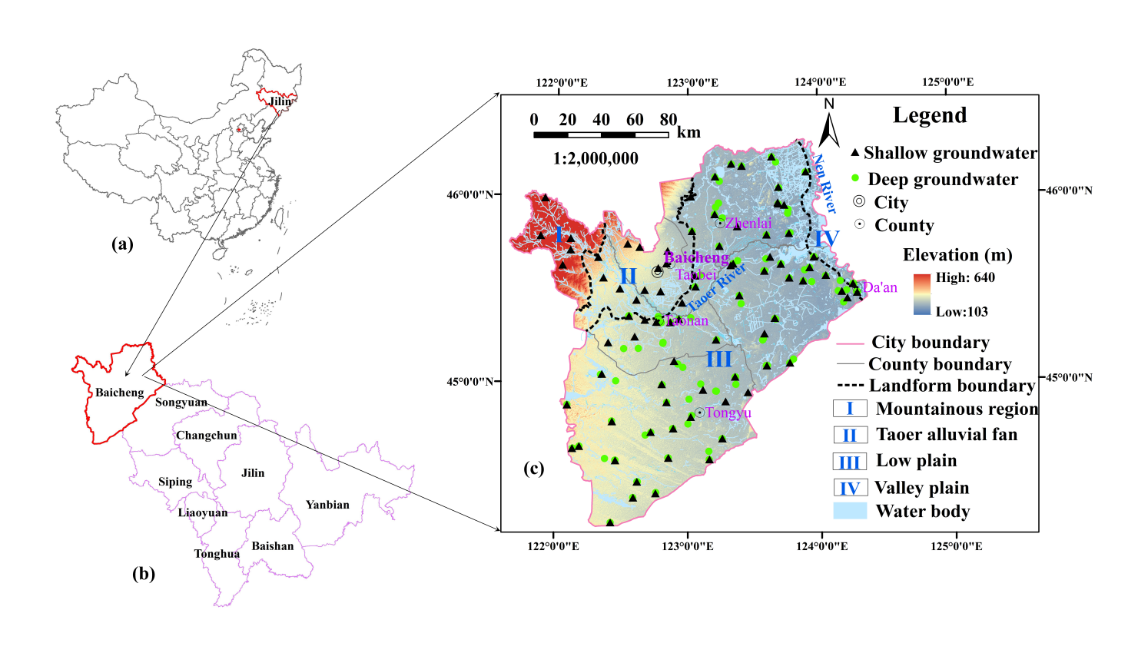

**Fig. 1.** Location of the Baicheng City (the study area) and its detailed information. (a). Jilin Province in the northeastern part of China (b). The spatial location of Baicheng City in Jilin Province (c). The topography, landform classification, sampling locations of the shallow and deep groundwater, and major rivers of Baicheng City

2.2 Materials

A sum of 86 shallow groundwater samples (well depth: 9.5 to 30 m) and 111 deep groundwater samples (well depth: 33 to 180 m) were gathered in Baicheng City in November, 2018 and their precise locations are illustrated in **Fig.1c**. At each site, two thoroughly cleaned polyethylene plastic bottles were used to store the groundwater, where 10% HNO3 was added to the one bottle to produce a pH < 2 environment for cation tests whereas no substances were added to the other bottle for the anion analysis. Both of them filtered through the 0.45 μm membrane to remove any impurities. Parameters like the alkalinity, pH were tested at the samples taking site via Gran titration and a calibrated HANNA (HI99131) portable pH analyzer, respectively. The concentrations of other chemical parameters were gained within a week from the Pony Testing International Group in Changchun, whose measuring techniques adhered to Chinese Drinking Water Criterion Detecting Methods(GB5750-2006). Major ions were detected using Ion chromatography (ICS-2000, Dionex) and ICP-MS (7500C, Agilent), including four key anions (Cl-, NO3-, SO42-, and F-) five principle cations (K+, Na+, Ca2+, Mg2+) respectively. The total arsenic was calculated with the use of HPLC-APC (highly performed liquid chromatography atomic fluorescence spectrometry). Moreover, the Steam-drying and the Na2EDTA titrimetric methods were employed to obtain the values of the total dissolved solids(TDS) and the total hardness(TH), respectively. All the samples have passed the charge-balance test because the values of E (%) were lower than 5.

 (1)

where E denotes the relative error; N+ andN- are the concentration in milliequivalents of the cation and anion, respectively (meq/L).

2.3 Methods

Health risk can be divided into two types: carcinogenic risk and non-carcinogenic risk in terms of the toxicity degree and the probability of causing cancer. For groundwater, oral exposure acted as the predominant cause of the adverse health risk to humans, compared with contact as there was an order of magnitude gap between contact and drinking according to former researches(Davraz & Batur, 2021; Wu & Sun, 2016). Therefore, only oral exposure was considered in this study. Substances like arsenic can not only trigger cancer but also trigger chronic diseases, therefore, its carcinogenic and non-carcinogenic health risk were both needed to consider.

2.3.1 HRE based on TFF model

Based on the widely used deterministic calculation of the health risk evaluation recommended by US EPA, a modified model-Triangular Fuzzy Figures(TFF) model was calculated as followed:

The calculation of the non-carcinogenic health risk:

 (2)

 (3)

The calculation of the lifetime carcinogenic health risk:

 (4)

where *Rn i* is the non-carcinogenic risk of a certain contaminant via oral exposure; *Rn* is the total non-carcinogenic risk(*Rn* > 1 indicated that the potential adverse risk was unacceptable; whereas *Rn* < 1 indicated an acceptable risk ); *CDIi* denotes the contents of a certain toxic substance that is consumed via the ingestion pathway (unit: mg/(kg·d)). Additionally, *Ci* is the concentration of a certain pollutant like NO3-, F- and As, (mg/L); *Ir* is the daily groundwater ingestion rate, (L); *EF* is the expose frequency, (d/a); *ED* is the exposure duration, which implies the number of years that individuals ingest groundwater containing a certain pollutant; *Bw* demotes the body weight, (kg); *At* is the average exposure time to a certain pollutant, (d). Then, *Rc* is the values of the carcinogenic risk and its classification is listed in **Table S1**. *RfDi* is the reference dose of the toxic substances like As, NO3-, and F-. *SFAs* is the slope factor of arsenic. Their respective values are shown in **Table S2.**

The procedure of the TFF model is shown in **Fig. 2**, where *Ci*, *Ir*, *EF*, and *Bw* were considered TFFs for non-carcinogenic risk and the concentration of arsenic (*CAs*), *Ir*, *EF*, and *Bw* were considered TFFs for carcinogenic risk. The TFFs of the shallow and deep groundwater of the toxic pollutants (As, F- and NO3-) in Baicheng City and its respective counties are listed in **Table S3** and **Table S4,** respectively. In light of the discrepancy in the parameters for different groups of people, children aged 3 to 8 and adults were taken into consideration in this study and their respective parameters are shown in **Table S5** .

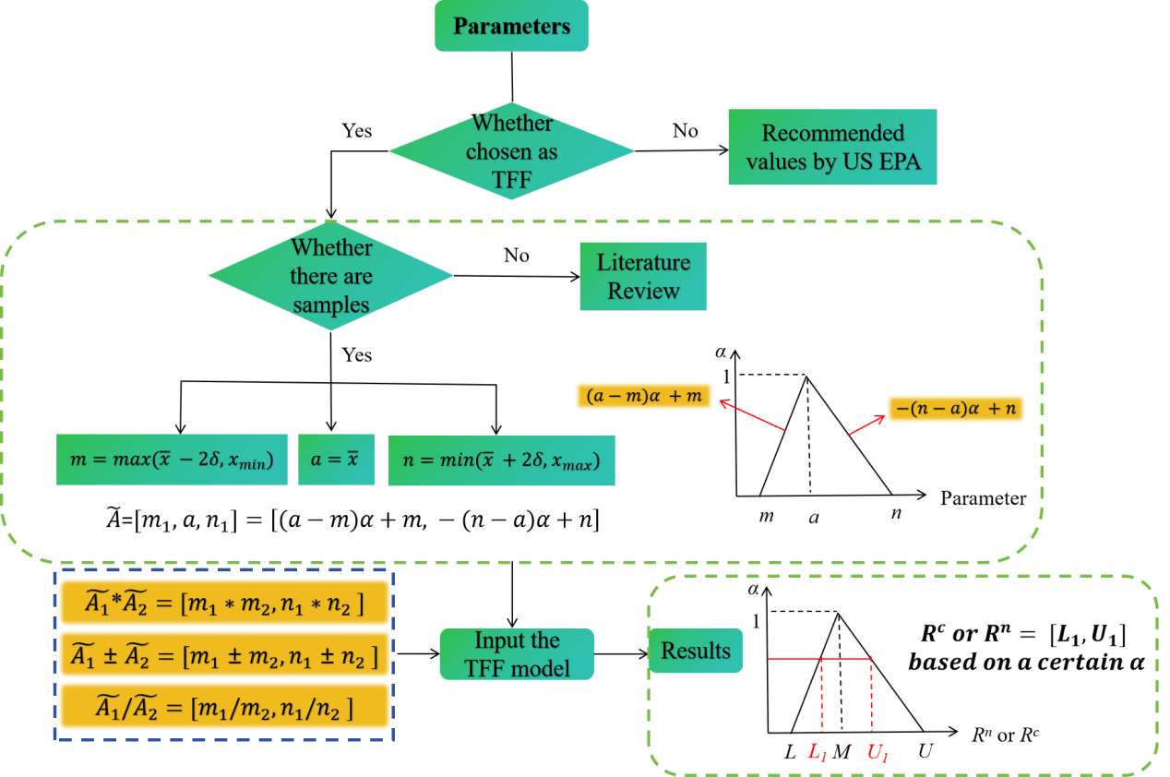

**Fig. 2.** The detailed calculation procedures for the TFF model

2.3.2 HRE based on TFF-Monte Carlo model

To greatly reduce the uncertainties of the deterministic models recommended by US EPA for calculating the carcinogenic and non-carcinogenic risks and to gain the precise values of the sensitivities of each parameters which were chosen as TFF, a modified model- TFF-Monte Carlo model was applied in this study. The inputs of the parameter values were the same as those of the TFF model as discussed above. A total of 10,000 iterations of random trials were conducted for each calculation.

**3.Results and Discussions**

3.1 Groundwater hydrogeochemistry

**Table 1** summarizes the statistical minimum, maximum, mean, median, S.D.(standard deviation), CV(coefficient variation ) and ER(exceeding rate of Chinese standard GB/T 14848-2017) of the eight chief ions, pH, F-, As, TDS(total dissolved solid) and TH(total hardness, CaCO3) in both 87 shallow groundwater samples and 111 deep groundwater samples.Based on the ER value, F- (45.98%), TH (22.99%), Na+ (22.99%), TDS (21.84%), As (14.94%), and NO3- (13.79%) were identified as the six contamination parameters in the shallow groundwater, whereas F- (35.14%), As (19.82%), and Na+ (11.71%) were considered to be the pollution variables in the deep groundwater samples. The groundwater quality in the deep aquifer was notably better than that of the shallow aquifer as the mean, median, and ER values of the parameters were lower in the deep aquifer, except for those of As. The higher values of TDS, TH, NO3-, and Cl- in the shallow phreatic groundwater were associated with intense and frequent anthropic interventions and the inherent climate features (intense evaporation) of the semi-arid region.

The sequence of the average milliequivalent percentage of the major anions of the shallow and deep groundwater was identical: HCO3- (shallow: 74.4%; deep: 82%) > Cl- (shallow: 14.9%; deep: 11.5%) > SO42- (shallow: 10.7%; deep: 6.5%). The order for the cations was: Ca2+ (37.7%) > Na+ (36.8%) > Mg2+ (25.3%) > K+ (0.2%) in the shallow groundwater and Na+ (45.8%) > Ca2+ (31.5%) > Mg2+ (22.3%) > K+ (0.4%) in the deep groundwater. The largest cation contributor was Na+ in the deep groundwater whereas Ca2+ in the shallow groundwater, which was likely due to cationic interchange in the relatively enclosed environment because evaporation is usually minimal in the deep groundwater. The hydrogeochemical types in the groundwater were dominated by HCO3-Ca, Mg type (61.6% in the shallow groundwater and 53.2% in the deep groundwater), and the HCO3-Na type (23.3% in the shallow groundwater and 40.5% in the deep groundwater) based on the Durov Diagram and the Chadha Diagram (Chadha, 1999) in **Fig. S1** and **Fig. S2**.

**Table 1.** Statistical data of the physicochemical variables of both 87 shallow groundwater samples and 111 deep groundwater samples in Baicheng City

|  |  |  |  |  |  |  |  |  |  |  |  |  |  |  |  |
| --- | --- | --- | --- | --- | --- | --- | --- | --- | --- | --- | --- | --- | --- | --- | --- |
| **Variables** | **Unit** | **Shallow groundwater(n = 87)** | | | | | | | **Deep groundwater(n = 111)** | | | | | | |
| **Min** | **Max** | **Mean** | **Median** | **S.D.** | **CV** | **ER(%)** | **Min** | **Max** | **Mean** | **Median** | **S.D.** | **CV** | **ER(%)** |
| **pH** | \ | 7.1 | 8.2 | 7.67 | 7.6 | 0.20 | 2.60 | 0 | 7.3 | 8.4 | 7.76 | 7.8 | 0.17 | 2.17 | 0 |
| **Ca2+** | mg/L | 19.5 | 341 | 87.60 | 73.7 | 57.42 | 65.56 | 0 | 8.45 | 174 | 58.93 | 53.5 | 33.52 | 56.88 | 0 |
| **Mg2+** | mg/L | 7.69 | 287 | 40.70 | 28.7 | 36.77 | 90.34 | 0 | 3.27 | 122 | 28.04 | 23.4 | 21.61 | 77.07 | 0 |
| **Na+** | mg/L | 13.1 | 548 | 125.41 | 81.7 | 121.39 | 96.80 | 22.99 | 16.9 | 376 | 107.32 | 93.9 | 71.99 | 67.07 | 11.71 |
| **K+** | mg/L | 0.286 | 2.65 | 1.05 | 0.919 | 0.47 | 45.14 | 0 | 0.452 | 2.26 | 1.21 | 1.14 | 0.43 | 35.65 | 0 |
| **HCO3-** | mg/L | 126 | 1900 | 524.64 | 455 | 291.02 | 55.47 | 0 | 152 | 980 | 481.16 | 442 | 192.30 | 39.97 | 0 |
| **SO42-** | mg/L | 1.78 | 659 | 76.09 | 32 | 119.86 | 157.53 | 5.75 | 0.09 | 596 | 42.09 | 14.3 | 82.62 | 196.28 | 3.60 |
| **Cl-** | mg/L | 2.99 | 1090 | 87.30 | 31.7 | 157.31 | 180.19 | 8.05 | 2.62 | 714 | 58.43 | 17.6 | 108.05 | 184.93 | 4.50 |
| **NO3-** | mg/L | 0.01 | 298 | 12.03 | 0.47 | 37.68 | 313.32 | 13.79 | 0.01 | 1.85 | 0.30 | 0.01 | 0.39 | 129.94 | 0.00 |
| **F-** | mg/L | 0.16 | 5.19 | 1.15 | 0.95 | 0.81 | 70.46 | 45.98 | 0.19 | 2.59 | 0.93 | 0.74 | 0.56 | 60.28 | 35.14 |
| **As** | mg/L | 0.001 | 0.31 | 0.01 | 0.001 | 0.04 | 342.47 | 14.94 | 0.001 | 0.148 | 0.01 | 0.001 | 0.03 | 225.40 | 19.82 |
| **TDS** | mg/L | 188 | 4340 | 789.42 | 603.5 | 601.35 | 76.18 | 21.84 | 160 | 2030 | 575.69 | 479 | 327.29 | 56.85 | 6.31 |
| **TH** | mg/L | 94.8 | 1860 | 397.95 | 318 | 274.67 | 69.02 | 22.99 | 36 | 949 | 272.81 | 245 | 165.70 | 60.74 | 9.01 |

3.2 Spatial distribution of the hazardous materials

High contents of fluorine and arsenic in the groundwater from Songnen Plain mainly caused by proto-geological processes is a common phenomenon, Baicheng City was no exception(Jianmin et al., 2015). The excessive arsenic contents in groundwater was mainly concentrated in TY and its neighbouring region-TN, both for the shallow and deep aquifer as illustrated in **Fig. 1**. Compared with the shallow groundwater, the exceeding rate as well as the mean value of the arsenic level in deep groundwater were even higher, posing huge threats to the local residents. In comparison with arsenic, the wider spatial distribution (mainly in the Low Plain) of exceeding fluorine levels in both shallow and deep groundwater of Baicheng City also posed health risks towards more local residents as shown in **Fig. 3**. Except for TB, other counties had fluorine-contaminated groundwater, among which TY and TN had the highest contents. As for the nitrate, high levels of nitrate were mainly spread in the southeast and northwest parts of the Baicheng City in terms of the shallow groundwater, and the nitrate levels of all the deep groundwater samples were lower than 2 mg/L, which was far below the Chinese standard of 20 mg/L. Therefore, residents in TY and TN are confronted with dual health risks due to groundwater arsenic and fluorine contamination.

High contents of arsenic in the groundwater were attributed to both complex geological processes and the anthropogenic inputs(Kumar et al., 2023). Pesticide usage, mining of metal deposits like copper, and landfill leaching are all examples of human interventions(Varol, 2021). Arsenic is thought to commonly co-exist with iron-oxide minerals(Nghiem et al., 2019). Under the proper reducing environment and water-rock interactions conditions, the migration of As from the minerals into the groundwater is the most general reason for groundwater arsenic contamination(Herath et al., 2016). Many arsenic-containing minerals at the edges of Songnen Plain like hematite, siderite, manganite, scorodite (FeAsO4·2H2O), calcium arsenate, and manganese arsenate offered a substance source for the accumulation of arsenic(Tang, 2014). A previous study of the southwestern parts of Songnen Basin demonstrated that both the shallow and deep aquifers manifested a slightly-mildly reducing environment, with an Eh value ranging from 103 to 272 mV (mean value: 151 mV) and 78.7 to 253 mV (mean value: 159 mV) in the shallow and deep aquifers, respectively(Guo et al., 2014), This to some extent can lead to an increase of arsenic in the aquifer in the anaerobic environment(Guo et al., 2003).

The crucial factors that caused abnormally high concentrations of fluorine in the groundwater from the low plain of Songnen Plain have been studied by many researchers (Adeyeye et al., 2021; Wang et al., 2021; Wang et al., 2023; Yan et al., 2020; Zhang et al., 2007). They can be summarized as follows: (1) the presence of fluorine-rich materials in the sediments and rocks like hieratite and prosopite; (2) the complex water-rock interactions like cation exchange that stimulated the transport and release of fluorine; and (3) the weak groundwater run-off in the low plain and strong evaporation in the semi-arid basin, which led to the accumulation of fluorine in the thick sediments.

Arsenic and fluorine were identified as two main parameters in PC2(Principal Component 2), which accounted for 14.25% of the total variance by employing Principal Component Analysis model as illustrated in **Table S6**. The moderately positive factor loadings for pH (0.603), HCO3- (0.519), F- (0.682), and As (0.541), relatively weakly positive factor loadings for Sodium(0.447), and weakly negative loadings for Calcium (-0.338) indicated that cationic interchange between calcium and nitrate and the pH influenced the accumulation of As and F. **Fig. S3** demonstrated that the excessive nitrate contents of the shallow groundwater were all affected by agricultural activities.

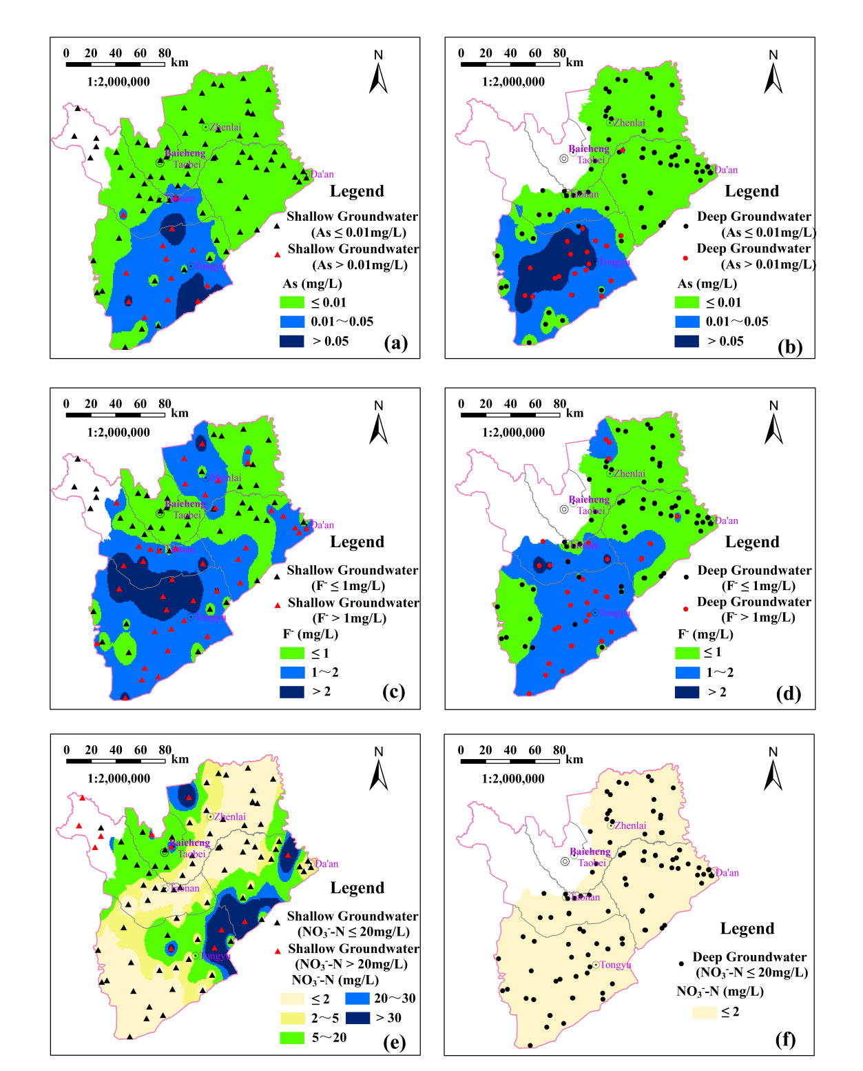

**Fig.3.** Spatial distribution of the potential contaminants in Baicheng City. (a). Arsenic in the shallow groundwater (b). Arsenic in the deep groundwater (c). Fluorine in the shallow groundwater (d). Fluorine in the deep groundwater (e). Nitrate in the shallow groundwater (f). Nitrate in the deep groundwater

3.3 HRE based on TFF model

Taking the jurisdictional and contamination differences among the counties and districts in Baicheng City into consideration, the non-carcinogenic (As, F-, NO3- and total) and carcinogenic health(As) risks from the oral ingestion of groundwater(shallow and deep) to both children and adults in Baicheng City and its five counties were examined using the triangular fuzzy figures(TFF) model. Due to the lack of distribution of the deep Quaternary and Neogene confined groundwater in the Taoer alluvial fan and the mountainous areas in the west as illustrated in **Fig.3**, three groups of counties (TY, TN + DA and TB + ZL) were considered for the deep groundwater.

Different interval values of health risks were gained based on the different confidence levels (α ∈ [0,1]) as illustrated in **Fig.4 and Fig.5**, among which α = 0 acted as the minimum and maximum threshold values while α = 1 was considered as the most possible values. When the confidence level (α) reached 0.8(a relatively high confidence level), for the shallow and deep groundwater according to **Fig.4 and Fig.5**, the total non-cancerous and cancerous risks for the kids were evidently higher than those for adults, implying that kids had a stronger vulnerability towards the potential contaminants compared with adults. When α = 0.8, the total *Rc* and *Rn* to kids and adults both to some extents exceeded the acceptable safe values of 10-4 and 1, demonstrating that the potential pollutants have more or less adverse cancerous and non-cancerous effect health risks.

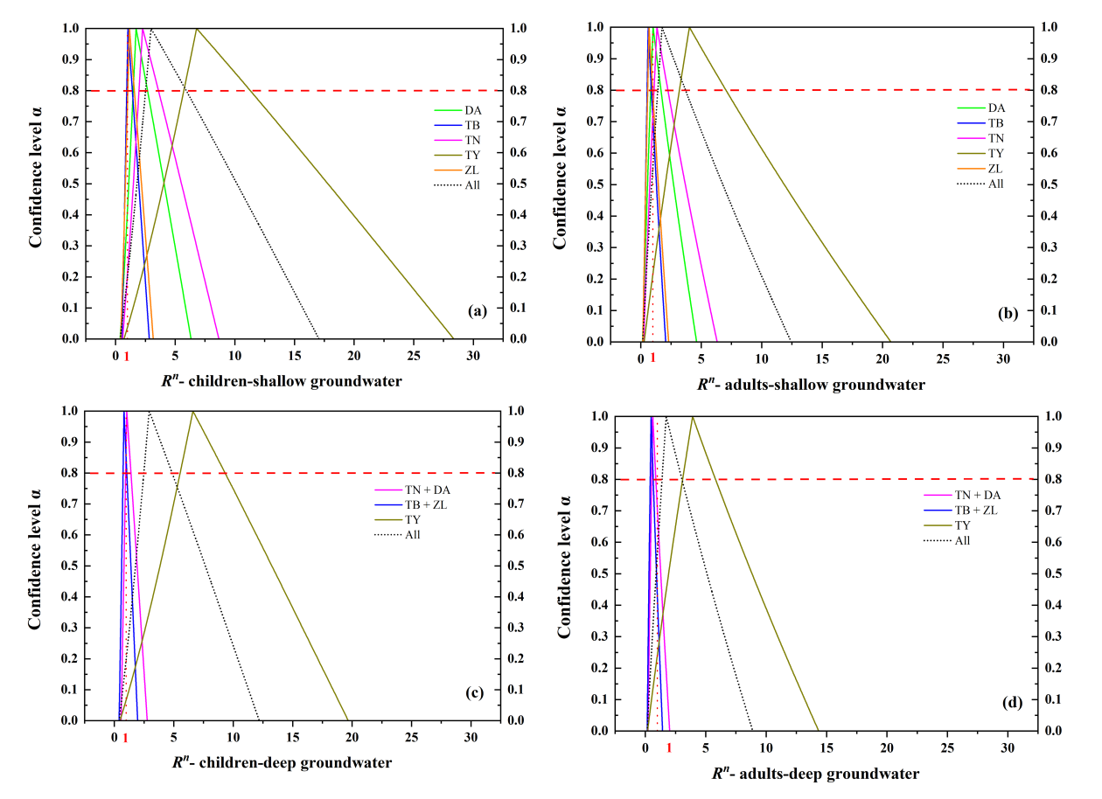

**Fig. 4.** The total non-carcinogenic health risk through oral consumption of groundwater. (a). Risk to children via drinking shallow groundwater. (b). Risk to adults via drinking shallow groundwater. (c). Risk to children via drinking deep groundwater. (d). Risk to adults via drinking deep groundwater. Abbreviations: TN, Taonan City; DA, Da’an City; TB, Taobei District; ZL, Zhenlai County; TY, Tongyu County.

3.3.1 Non-carcinogenic risk

When α = 0, the ranges of the non-carcinogenic risk values were the largest, demonstrating the largest fuzziness. The values ranged from 0.37 to 11.06, and 0.15 to 12.44 for the direct consumption of shallow groundwater by kids and adults, respectively, with the percentage of unacceptable risk being 94.1% and 93.1% for children and adults, respectively. For deep groundwater, the values fluctuated from 0.41 to 12.22 and 0.16 to 8.9 for the kids and adults, respectively, with the percentage of unacceptable risk being 95% and 90.4% for the kids and adults, respectively. The values of the ranges (maximum value minus minimum value) were consistent with the unacceptable rate in terms of the counties when α = 0, whose sequence is TY(children: 98.9%;adults: 96.5%)>TN (children:95%;adults: 87.4%)> DA (children: 89.7%;adults: 81%)> ZL(children: 79.4%;adults: 61%)>TB(children: 79.6%; 57.3%) in shallow groundwater and TY(children: 97.3%; adults: 94.3%) > TN+DA(children: 80.5%; adults: 56.7%)> TB+ZL(children: 61.9%; adults: 33.9%) in deep groundwater based on **Table S7 and Table S8.**

When α = 1, the values of *Rn* of kids and adults were 2.97 and 1.76, and 2.93 and 1.74 for the shallow groundwater and deep groundwater respectively, which all exceeded the safety threshold of 1 and were indicative of potentially adverse non-cancerous hazards. However, as illustrated in **Fig. S4**, significant differences between different counties were existed in terms of the *Rn* values. Specifically, TY had the highest degrees of non-carcinogenic risks both in shallow and deep groundwater compared with other counties due to the severe arsenic pollution. The *Rn* values for the adults in TB and ZL were acceptable as they were below the threshold value of 1. The sequence of the *Rn* values was as follows in the shallow groundwater: TY (children: 6.8; adults: 4.03) > TN (children: 2.27; adults: 1.34) > DA (children: 1.72; adults: 1.02) > ZL (children: 1.17; adults: 0.69) > TB (children: 1.04; adults: 0.62); the order for the deep groundwater was as follows: TY (children: 6.61; adults: 3.92) > TN + DA (children: 1.04; adults: 0.62) > TB + ZL (children: 0.82; adults: 0.48).

The average values(α = 1) of non-carcinogenic risk(*Rn*) of the parameters (NO3-, F- and As) in both the shallow and deep groundwater for the kids and adults were shown in **Fig S5**. NO3- was the only parameter whose *Rn* values of all the counties in both shallow and deep aquifers were lower than 1, indicating that they were relatively acceptable and did not pose a severe health risk to humans. Due to the relatively enclosed environment of the deep aquifer and nearly no influenced by the agricultural activities, the values of the *RNn* were much lower than 1(average 0.0066). Overall, groundwater in both shallow and deep aquifers in TY had severe arsenic contamination as discussed in **3.2**, therefore, the mean arsenic non-carcinogenic risks for the children and adults in TY were apparently higher than those in the other counties and districts in Baicheng City.

3.3.2 Arsenic carcinogenic risk

According to **Fig. 5**, the larger the confidence levels were, the narrower the value range (the difference between the lower and upper values) of the *Rc* , among which α = 0 had the widest range of *Rc* values: 4.31 × 10-5 to 2.02 × 10-3 and 1.69 × 10-5 to 1.47 × 10-3 for children and adults respectively in shallow groundwater; 4.31 × 10-5 to 1.7 × 10-3 and 1.69 × 10-5 to 1.24 × 10-3 for children and adults respectively in deep groundwater. There was no doubt that residents in Baicheng City had a high possibility of suffering from cancer through the direct ingestion of groundwater because the high and very high cancerous risk of the shallow groundwater was 97.12% and 94.28% for children and adults, respectively, and that of the deep groundwater was 96.56% and 93.19% for children and adults, respectively. However, there were obvious discrepancies in terms of the *Rc* due to the different levels of arsenic contamination in the different counties as illustrated in **Fig. 3**. According to **Fig. S6**, the order of the average values of high and very high (Grade IV and Grade V) carcinogenic possibilities for the children and adults were as follows: TY (97.78%) > TN (89.5%) > TB (45%) > ZL (4.38%) > DA (0.76%) in the shallow groundwater and TY (96.99%) > TN + DA( 50.17%) > TB + ZL (27.88%) in the deep groundwater.

When α = 1, the values of the *Rc* were fixed with a minimum range of 0, which was equivalent to the mean risk value that was calculated using the USEPA deterministic model. The most possible values of carcinogenic risk for kids and adults through the ingestion of groundwater were 3.1 × 10-4 and 1.84 × 10-4 in the shallow aquifer, respectively, and 3.95 × 10-4 and 2.33 × 10-4 in the deep aquifer, respectively as illustrated in **Table S9** and **Table S10**. These exceeded the USEPA recommended lower boundary of the safety threshold (10-4) and belonged to Grade-III (medium) risk, which indicates that remediation measures should be taken to alleviate the arsenic pollution in both the shallow and deep aquifers of Baicheng City to greatly lower the possibilities of local residents getting cancer. In comparison with the adults, more attention should be paid to local children aged 3 to 8 years old as they had a higher possibility of getting cancer through directly drinking groundwater with the *Rc* 1.69 times larger than that of the adults.

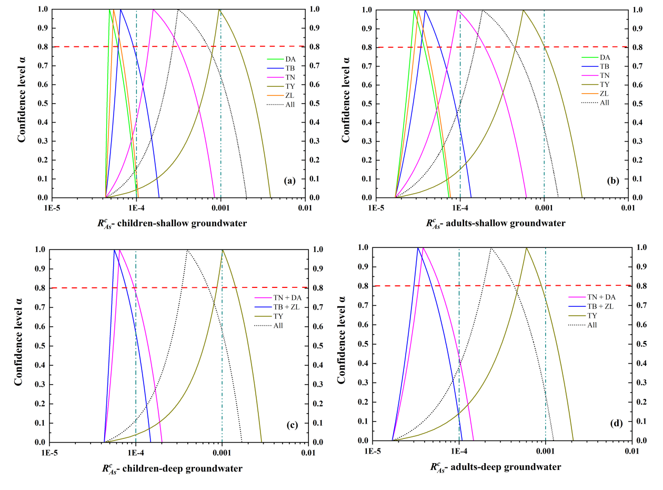

**Fig. 5.** The arsenic carcinogenic health risk through oral consumption of groundwater. (a). Risk to children via drinking shallow groundwater. (b). Risk to adults via drinking shallow groundwater. (c).Risk to children via drinking deep groundwater. (d). Risk to adults via drinking deep groundwater. Abbreviations: TN, Taonan City; DA, Da’an City; TB, Taobei District; ZL, Zhenlai County; TY, Tongyu County.

3.4 HRE based on TFF-Monte Carlo model

The prediction of the cumulative possibility distribution and possibility density of the non-cancerous and lifetime cancerous risks for children and adults in Baicheng City based on TFF-Monte Carlo model are shown in **Fig. 6 and Fig.7**, respectively. The 95% probability and the mean *Rn* values were 14.867 and 7.573(children), 8.253 and 4.37(adults) in the shallow aquifer, respectively; 11.482 and 5.697(children), 6.523 and 3.302(adults) in the deep aquifer, respectively. All of those values were higher than 1, which indicated that they were unacceptable and chronic harms should be noted by the local authorities, especially for the children as their *Rn* values were approximately 1.77 times higher than those of the adults. The **Fig. 8** and **Fig. 9** demonstrate cumulative probability distribution curves of the NO3-, F- and As non-carcinogenic risk in different counties and districts of Baicheng City, both for the shallow and deep groundwater. The sequence of average values of the total non-carcinogenic risk were as followed: TY > TN > DA > ZL > TB in the shallow aquifer and TY > TN + DA > TB + ZL in the deep aquifer. According to **Fig. 3**, the spatial distribution of the non-carcinogenic risk degrees was closely associated with the contamination status of the parameters. The shallow and deep aquifers in TY had elevated As concentrations, which caused the residents to have the highest likelihood of chronic As-related non-carcinogenic risk (about 28 times higher than that of the lowest counties). As the surrounding county of TY, TN also had relatively unacceptable health risk outcome. In terms of As, the order of the *Rn As* was: TY > TN > TB > ZL > DA in shallow aquifer and TY > TN+DA > TB + ZL in deep aquifer as illustrated in **Fig. 8** and **Fig. 9**, which was similar to the sequences of values of the total non-cancerous risk and reflected that *Rn As* contributed a lot to the *Rn*. As for nitrate, deep groundwater was nearly impossible to cause health risk problems to Baicheng City, however, the surface NO- 3 pollution of the shallow groundwater was likely to pose medium risk towards the children and adults in DA. Additionally, though the average values of the *Rn N* for children was acceptable in TY and TN, it was exceeding the standard 1 regarding the 95% *Rn N* and also needed to be noted. Children aged 3 to 8 of all the counties were confronted with more or less fluorine health risk through oral ingestion of the shallow and deep groundwater, whereas adults were relatively safe except for TY and TN, reflecting that children was more vulnerable to the fluoride-contaminated groundwater.

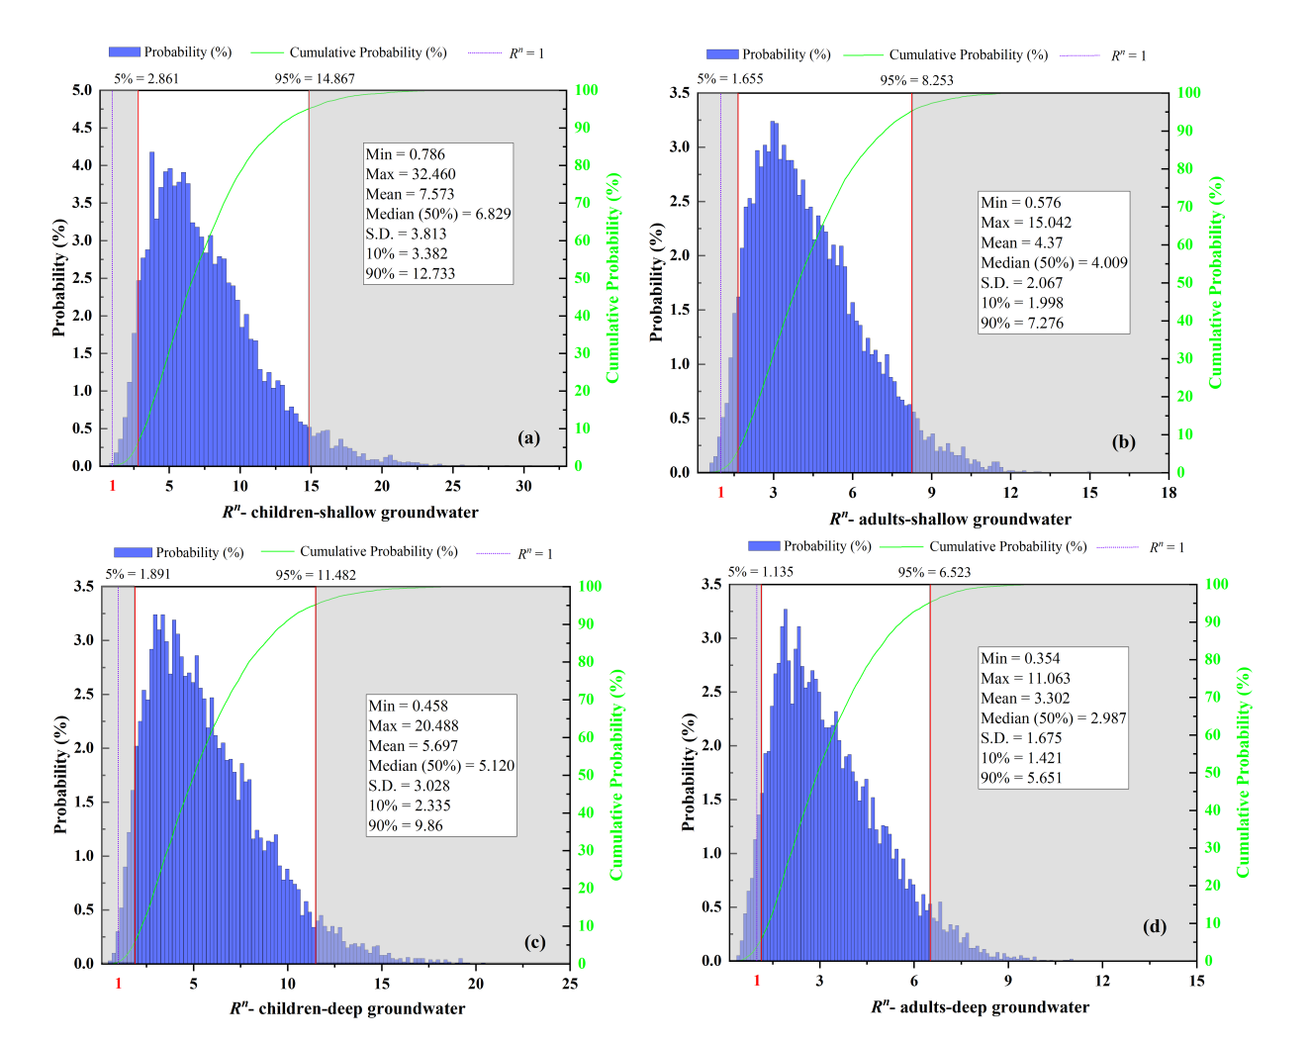

**Fig. 6.** Frequency distributions of the non-carcinogenic risk of oral exposure to the potential contaminants in the groundwater and their cumulative probabilities. (a) Risk to children via drinking shallow groundwater (b). Risk to adults via drinking shallow groundwater (c). Risk to children via drinking deep groundwater (d). Risk to adults via drinking deep groundwater. Abbreviations: S.D., standard deviation.

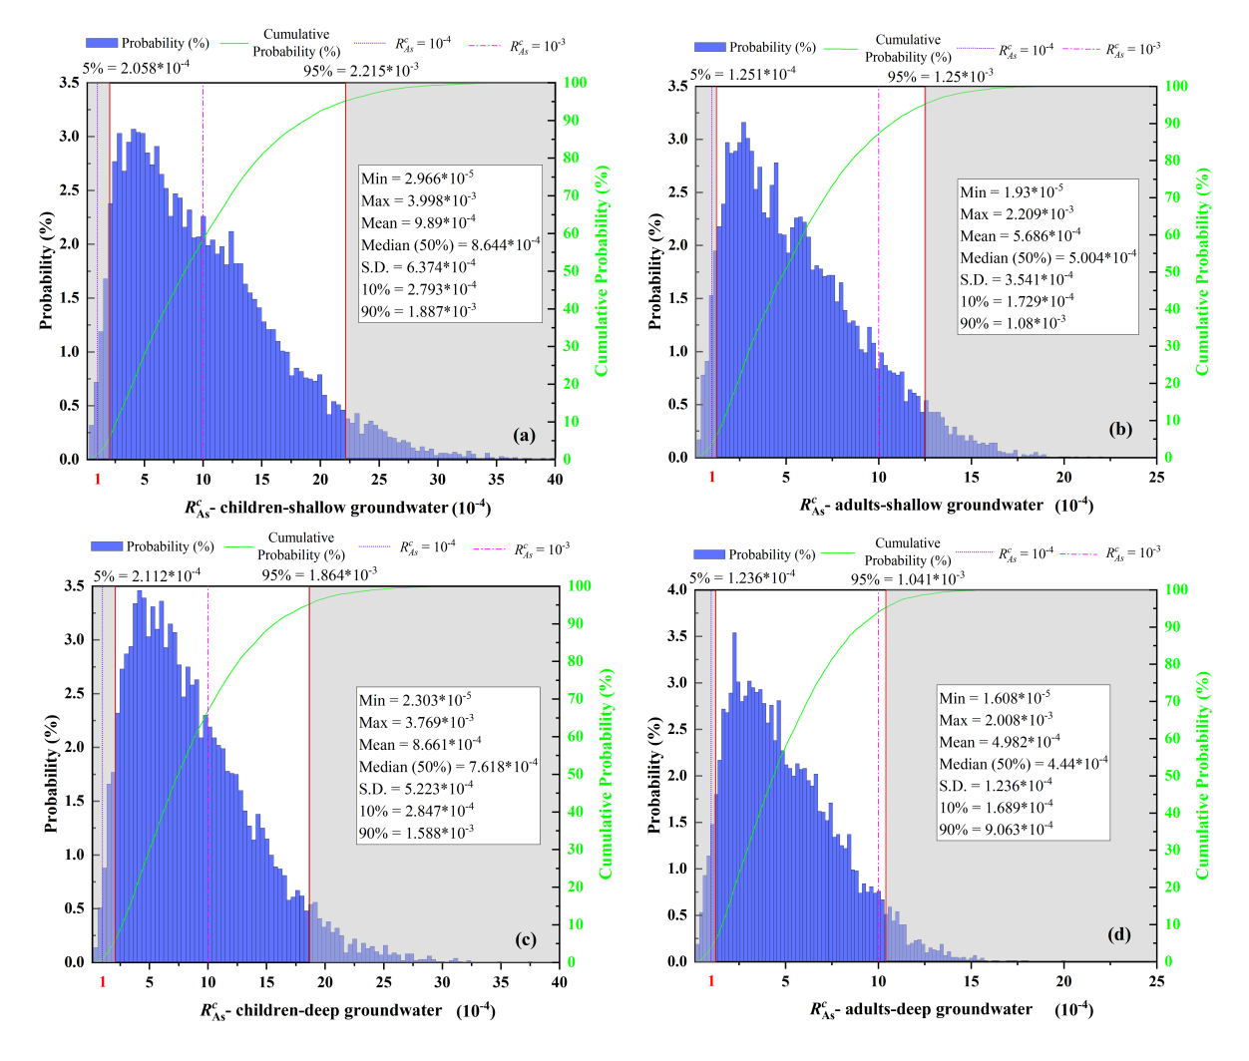

**Fig. 7.** Frequency distributions of the arsenic carcinogenic risk of oral exposure to the potential contaminants in groundwater and their cumulative probabilities. (a) Risk to children via drinking shallow groundwater (b). Risk to adults via drinking shallow groundwater (c). Risk to children via drinking deep groundwater (d). Risk to adults via drinking deep groundwater. Abbreviations: S.D., standard deviation.

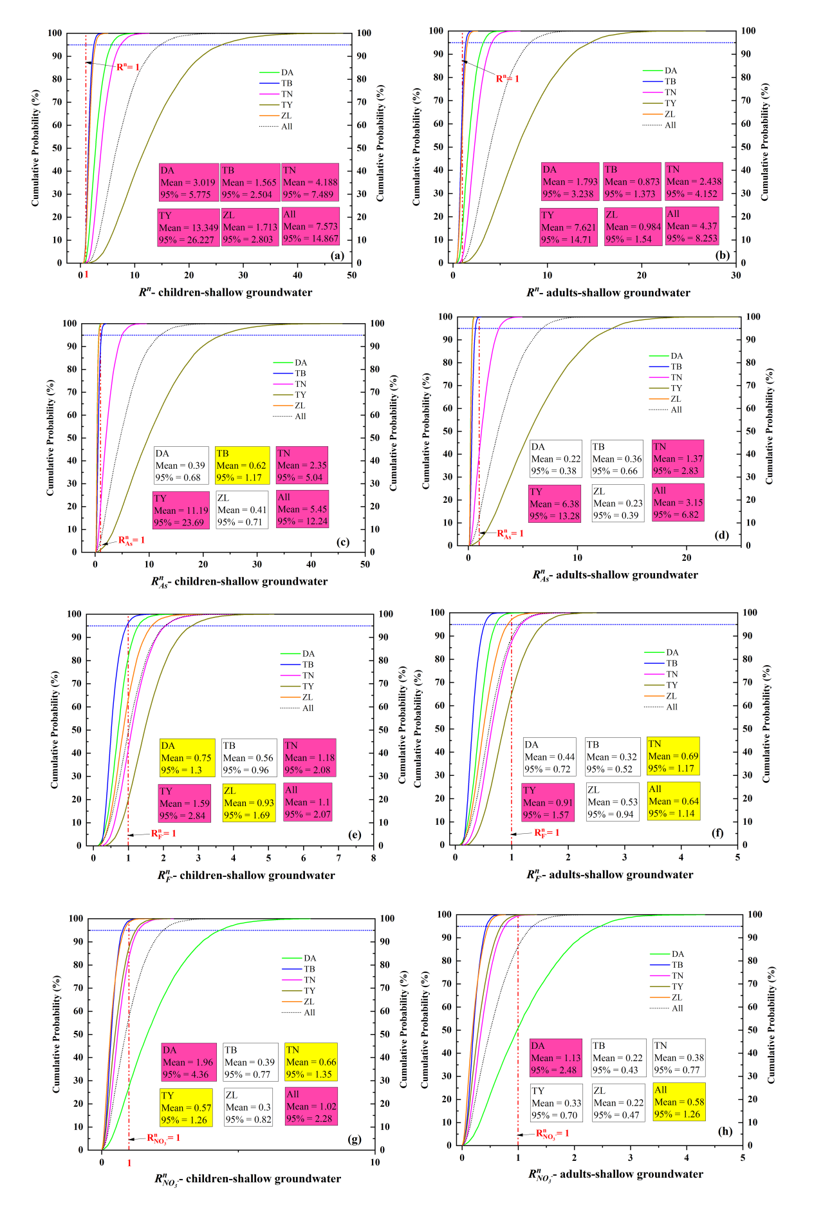

**Fig. 8.** Probabilistic distributions of the non-carcinogenic(total, arsenic, fluorine, and nitrate) risk of the contaminants via direct ingestion of the shallow groundwater within the different counties of Baicheng City. (a). Total risk for children (b). Total risk for adults (c). Arsenic risk for children (d). Arsenic risk for adults (e). Flouride risk for children (f). Flouride risk for adults (g). Nitrate risk for children (h). Nitrate risk for adults.

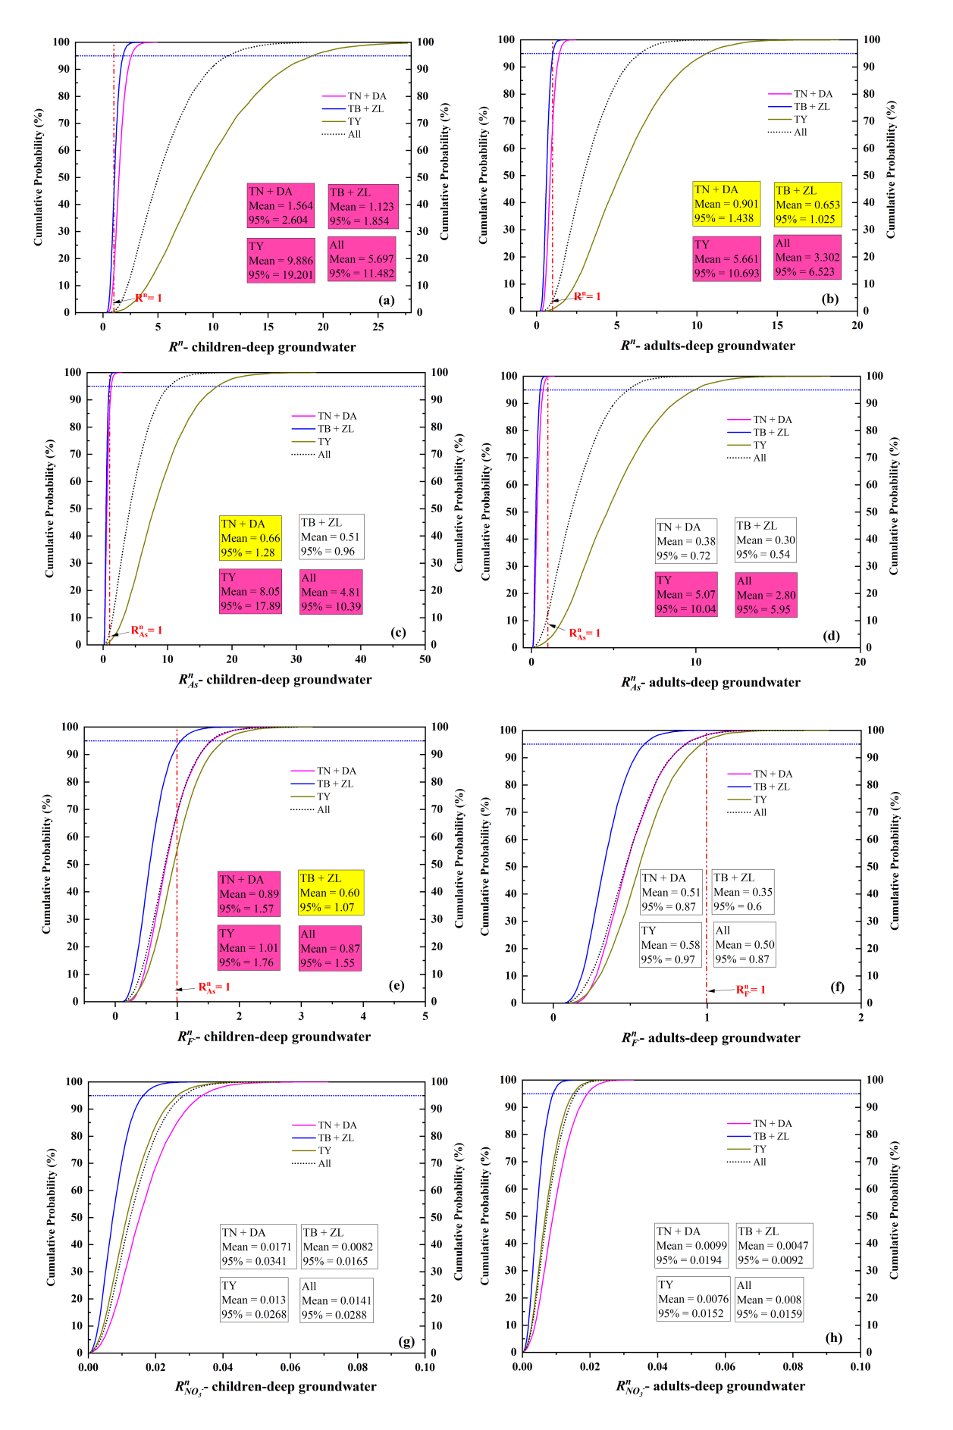

**Fig. 9.** Probabilistic cumulative distributions of the non-carcinogenic(total, arsenic, fluorine, and nitrate) risk of the contaminants via direct ingestion of the deep groundwater within the different counties of Baicheng City. (a). Total risk for children (b). Total risk for adults (c). Arsenic risk for children (d). Arsenic risk for adults (e). Flouride risk for children (f). Flouride risk for adults (g). Nitrate risk for children (h). Nitrate risk for adults.

As a trace element, the excessive concentrations of arsenic not only trigger non-cancerous health hazards but also trigger tremendous carcinogenic hazards. Through the TFF-Monte Carlo model, the values of the mean and 95% probability of cancerous risks in Baicheng City all greatly exceed the maximum acceptable 10-4 as illustrated in **Fig.7**, mainly distributed in TY and its surrounding areas combined with **Fig.10** and **Fig.3**. The variation of the *Rc As* hazard levels in different regions of Baicheng City was: TY >TN > TB > ZL > DA in shallow groundwater and TY >TN + DA > TB +ZL in deep groundwater.

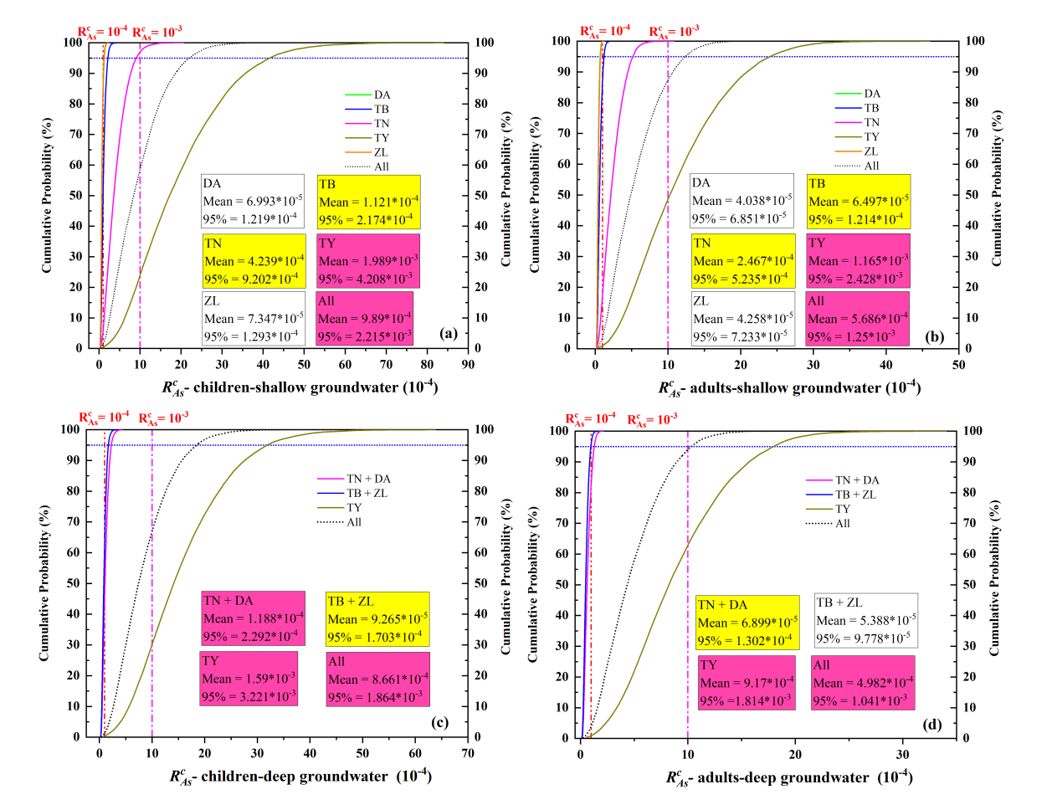

**Fig. 10.** Probabilistic cumulative distributions of the arsenic cancerous risk of the direct ingestion of the groundwater within the different counties of Baicheng City. (a). Cancerous risk via ingestion of shallow groundwater for children (b). Cancerous risk via ingestion of shallow groundwater for adults (c). Cancerous risk via ingestion of deep groundwater for children (d). Cancerous risk via ingestion of deep groundwater for adults.

3.5 Sensitivity analysis

A sensitivity analysis was performed to find out the significant contributors to the probabilistic evaluation results of the carcinogenic and non-carcinogenic risks of the different counties and different layers of aquifers, which would be helpful to lead the local government to carry out more accurate and effective strategies and corresponding ways to guarantee the safe drinking water of the local residents. The contribution rate of each parameter to the *Rc*(*Ir*, *CAs*, *EF*, *Bw*, *At*) and *Rn*(*Ir*, *CAs*, *CNO- 3*, *CF-*, *EF*, *Bw*) in different regions of Baicheng City were plotted in **Fig.11.** Overall, the concentrations of the arsenic(*CAs*) in Baicheng City contributed the most to the results of the calculation of *Rn* of children and adults in shallow groundwater, followed by daily groundwater ingestion rate(*Ir*), the concentrations of nitrate(*CNO- 3*), exposure frequency(*EF*) and the concentrations of fluorine(*CF-*), however, body weight(*Bw*) acted as the parameter having the largest negative impacts. For the deep groundwater, the sensitivity results were basically the same as those for the shallow groundwater, except that nitrate had no influence because all the groundwater samples fell within the standard. Discrepancies were existed in view of the largest contributors to the outcomes of the non-cancerous risks in different counties of Baicheng City: though the arsenic contents were the most sensitive factors in the shallow groundwater of TY and TN, the nitrate contents and the fluorine concentrations were the most sensitive factors in DA and ZL, respectively, which demonstrated that accurate and different corresponding strategies should be taken to greatly decrease the health risks in different regions. However, a thing should be noted that the figure of contribution rate of a certain region was the relative importance of a parameter to the region itself: region like TY had more than one exceeding substance, top priorities should be given to effectively lower arsenic contents, which didn’t mean that the pollution of fluorine and nitrate could be neglected.

For the sensitivity analysis of the lifetime cancer risk due to arsenic, the As concentration of the groundwater was the major factor that had the largest positive effect, which was followed by the ingestion rate, whereas the *At* and *Bw* had negative influences. Therefore, lowering the As of the groundwater is the most effective method to greatly decrease the residents’ likelihood of getting cancer via direct drinking of the groundwater. Other potential cancer-triggering toxic materials, like Cr and Cd, were not considered in this study and should be investigated in future research.

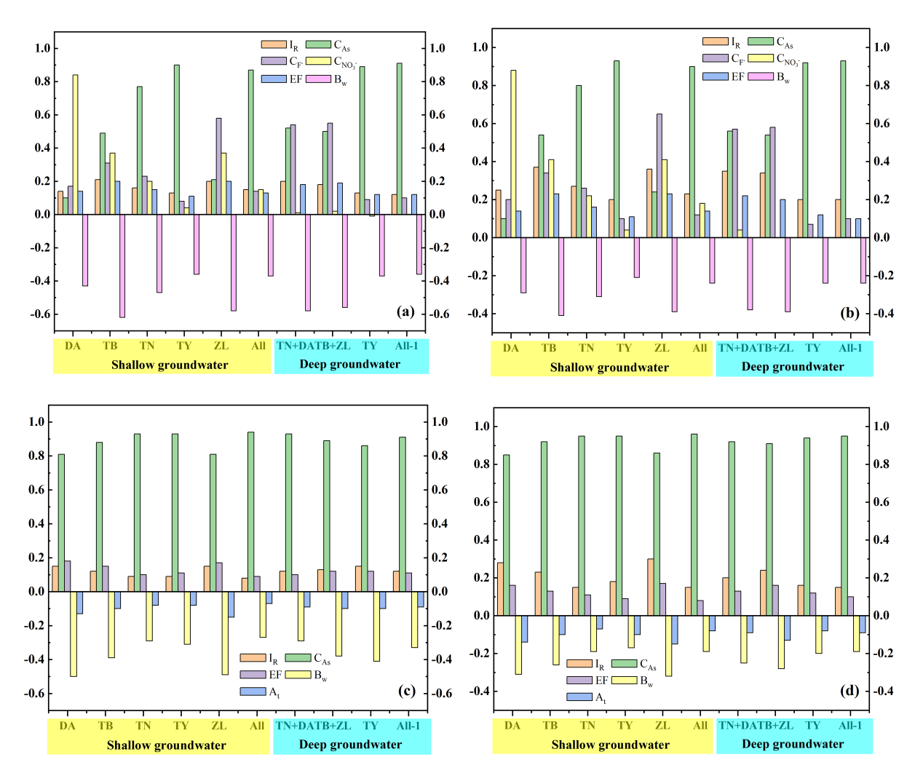

**Fig. 11.** Contribution rate of the parameters in both the non-carcinogenic and carcinogenic risk model. (a). Total non-carcinogenic risk for children (b). Total non-carcinogenic risk for adults (c). Arsenic carcinogenic risk for children (d). Arsenic carcinogenic risk for adults.

**Conclusion**

The potential hazardous materials in the groundwater of Baicheng City were identified in this study, namely the regional abnormal concentrations of arsenic and fluorine caused by complex proto-geological processes and regional high levels of nitrate caused by human inputs. Additionally, the total non-carcinogenic and arsenic carcinogenic HRE was conducted considering the different age groups (children aged 3 to 8 and adults), different aquifers, and different jurisdictional regions (counties). The findings are summarized below.

1. According to the TFF and TFF-Monte Carlo models, the total non-carcinogenic and carcinogenic risks for kids(3 to 8 years old) and adults in Baicheng City had high probabilities of exceeding the safety value but discrepancies existed in terms of the depths of the aquifers and the different counties. The order of the non-carcinogenic risks was as follows: TY > TN > DA > ZL > TB in shallow groundwater and TY>TN+DA>TB+ZL in deep groundwater. The sequence of the arsenic carcinogenic risks was as follows: TY > TN > TB > ZL > DA in shallow groundwater and TY>TN+DA>TB+ZL in deep groundwater. The residents in TY were confronted with dual hazards caused by arsenic and fluorine contamination, which resulted in the largest *Rn* values. Residents in TY and TN also had the highest possibilities of suffering from cancer through direct drinking the groundwater, which was high in arsenic, both from the shallow and deep aquifers. Compared with adults, children are more vulnerable to the potential hazardous materials due to the parameter discrepancies.
2. The sensitivity analysis demonstrated that the high values of carcinogenic and non-carcinogenic risks in Baicheng City were highly associated with the concentrations of arsenic in the groundwater. Lowering the concentrations of arsenic from the shallow and deep groundwater in TY and DA should be prioritized to lower the possibilities of cancerous and non-cancerous risks to local kids and adults to great extents. Moreover, the high nitrate contents in the shallow groundwater in DA and the high fluorine contents in ZL also need to be noted by the local authorities as they contributed the most to their non-carcinogenic risk.

**Acknowledgements**

We would be grateful to the anonymous reviewers and the editor for providing valuable and helpful suggestions.

**CRediT authorship contribution statement**

**Xinkang Wang:** Conceptualization,Formal analysis, Investigation, Methodology, Software, Validation, Visualization, Roles/Writing-original draft **Changlai Xiao:** Funding acquisition,Resources, Supervision, Project administration, Writing-review and editing **Weifei Yang:** Investigation, Project administration, Supervision, Writing-review and editing **Jinwei Cheng:** Investigation, Data curation, Visualization, Formal analysis **Xiujuan Liang：**Conceptualization, Funding acquisition, Project administration, Supervision **Linzuo Zhang:** Data curation, Investigation **Jiang Zhang:** Formal analysis, Methodology

**Funding**

This study was supported by the National Natural Science Foundation of China (Grant number: 42307076 and 41572216 ), the Geological Exploration Fund Management Center of Jilin Province(2018-11), the Geological Exploration Fund Management Center of Jilin Province (2018-13) and the Geological Exploration Fund Management Center of Jilin Province (2021 xu-1)

**Declarations**

**Ethical approval and consent to participate:** Not applicable.

**Consent to publish:** Not applicable.

**Completing interests:** The authors declare no completing interests.

**References**

Adeyeye, O. A., Xiao, C. L., Yawe, A. S., Zhang, Z. H., Yang, W. F., Nnanwuba, U. E., & Liang, X. J. (2023). Temporal groundwater quality, health risks and source point management zonation of multi-aquifers in Jilin Qian'an, Northeastern China. *Environ. Geochem. Health*, *45*(8), 6069-6094. <https://doi.org/10.1007/s10653-023-01622-8>

Adeyeye, O. A., Xiao, C. L., Zhang, Z. H., Yawe, A. S., & Liang, X. J. (2021). Groundwater fluoride chemistry and health risk assessment of multi-aquifers in Jilin Qianan, Northeastern China. *Ecotox. Environ. Safe.*, *211*, Article 111926. <https://doi.org/10.1016/j.ecoenv.2021.111926>

Adimalla, N., & Qian, H. (2019). Groundwater quality evaluation using water quality index (WQI) for drinking purposes and human health risk (HHR) assessment in an agricultural region of Nanganur, south India. *Ecotox. Environ. Safe.*, *176*, 153-161. <https://doi.org/10.1016/j.ecoenv.2019.03.066>

Bing, Z. (2009). *Study on enrichment laws and influencing factors of arsenic and fluorine in groundwater in the Songnen Plain* Jilin University].

Chadha, D. K. (1999). A proposed new diagram for geochemical classification of natural waters and interpretation of chemical data. *Hydrogeol. J.*, *7*(5), 431-439. <https://doi.org/10.1007/s100400050216>

Davraz, A., & Batur, B. (2021). Hydrogeochemistry characteristics of groundwater and health risk assessment in Yalvac-Gelendost basin (Turkey). *Appl. Water Sci.*, *11*(4), Article 67. <https://doi.org/10.1007/s13201-021-01401-9>

Fallahzadeh, R. A., Ghaneian, M. T., Miri, M., & Dashti, M. M. (2017). Spatial analysis and health risk assessment of heavy metals concentration in drinking water resources. *Environ. Sci. Pollut. Res.*, *24*(32), 24790-24802. <https://doi.org/10.1007/s11356-017-0102-3>

Gao, Y. Y., Qian, H., Zhou, Y. H., Chen, J., Wang, H. K., Ren, W. H., & Qu, W. G. (2022). Cumulative health risk assessment of multiple chemicals in groundwater based on deterministic and Monte Carlo models in a large semiarid basin. *J. Clean Prod.*, *352*, Article 131567. <https://doi.org/10.1016/j.jclepro.2022.131567>

Gholami, V., & Sahour, H. (2023). A Hybrid Approach of Supervised Self-organizing Maps and Genetic Algorithms for Predictive Mapping of Arsenic Pollution in Groundwater Resources. *Expo. Health*. <https://doi.org/10.1007/s12403-023-00592-7>

Guo, H., Zhang, D., Wen, D., Wu, Y., Ni, P., Jiang, Y., Guo, Q., Li, F., Zheng, H., & Zhou, Y. (2014). Arsenic mobilization in aquifers of the southwest Songnen basin, PR China: Evidences from chemical and isotopic characteristics [Article]. *Sci. Total Environ.*, *490*, 590-602. <https://doi.org/10.1016/j.scitotenv.2014.05.050>

Guo, H. M., Wang, Y. X., Shpeizer, G. M., & Yan, S. L. (2003). Natural occurrence of arsenic in shallow groundwater, Shanyin, Datong Basin, China [Article]. *J. Environ. Sci. Health Part A-Toxic/Hazard. Subst. Environ. Eng.*, *38*(11), 2565-2580. <https://doi.org/10.1081/ese-120024447>

He, X. D., Li, P. Y., Ji, Y. J., Wang, Y. H., Su, Z. M., & Vetrimurugan, E. (2020). Groundwater Arsenic and Fluoride and Associated Arsenicosis and Fluorosis in China: Occurrence, Distribution and Management. *Expo. Health*, *12*(3), 355-368. <https://doi.org/10.1007/s12403-020-00347-8>

Herath, I., Vithanage, M., Bundschuh, J., Maity, J. P., & Bhattacharya, P. (2016). Natural Arsenic in Global Groundwaters: Distribution and Geochemical Triggers for Mobilization. *Curr. Pollut. Rep.*, *2*(1), 68-89. <https://doi.org/10.1007/s40726-016-0028-2>

Jadhav, S. V., Bringas, E., Yadav, G. D., Rathod, V. K., Ortiz, I., & Marathe, K. V. (2015). Arsenic and fluoride contaminated groundwaters: A review of current technologies for contaminants removal. *J. Environ. Manage.*, *162*, 306-325. <https://doi.org/10.1016/j.jenvman.2015.07.020>

Jianmin, B., Yu, W., & Juan, Z. (2015). Arsenic and fluorine in groundwater in western Jilin Province, China: occurrence and health risk assessment [Article]. *Nat. Hazards*, *77*(3), 1903-1914. <https://doi.org/10.1007/s11069-015-1682-1>

Kumar, V., Maity, A., Kumar, A., Saha, S., Kay, P., Singh, B., & Mukherjee, T. (2023). Critical review on uranium and arsenic content and their chemical mobilization in groundwater: A case study of the Malwa region Punjab, India. *Sci. Total Environ.*, *885*, Article 163885. <https://doi.org/10.1016/j.scitotenv.2023.163885>

Li, P. Y., He, X. D., Li, Y., & Xiang, G. (2019). Occurrence and Health Implication of Fluoride in Groundwater of Loess Aquifer in the Chinese Loess Plateau: A Case Study of Tongchuan, Northwest China. *Exposure and Health*, *11*(2), 95-107. <https://doi.org/10.1007/s12403-018-0278-x>

Li, Z. J., Yang, Q. C., Xie, C., Wang, H., & Wang, Y. L. (2022). Spatiotemporal characteristics of groundwater quality and health risk assessment in Jinghe River Basin, Chinese Loess Plateau. *Ecotox. Environ. Safe.*, *248*, Article 114278. <https://doi.org/10.1016/j.ecoenv.2022.114278>

Liu, M. J., Xiao, C. L., Liang, X. J., & Wei, H. Y. (2022). Response of groundwater chemical characteristics to land use types and health risk assessment of nitrate in semi-arid areas: A case study of Shuangliao City, Northeast China. *Ecotox. Environ. Safe.*, *236*, Article 113473. <https://doi.org/10.1016/j.ecoenv.2022.113473>

Nghiem, A. A., Stahl, M. O., Mailloux, B. J., Mai, T. T., Trang, P. T., Viet, P. H., Harvey, C. F., van Geen, A., & Bostick, B. C. (2019). Quantifying Riverine Recharge Impacts on Redox Conditions and Arsenic Release in Groundwater Aquifers Along the Red River, Vietnam. *Water Resour. Res.*, *55*(8), 6712-6728. <https://doi.org/10.1029/2019wr024816>

Rahmati, O., Pourghasemi, H. R., & Melesse, A. M. (2016). Application of GIS-based data driven random forest and maximum entropy models for groundwater potential mapping: A case study at Mehran Region, Iran. *Catena*, *137*, 360-372. <https://doi.org/10.1016/j.catena.2015.10.010>

Rajasekhar, B., Nambi, I. M., & Govindarajan, S. K. (2020). Human health risk assessment for exposure to BTEXN in an urban aquifer using deterministic and probabilistic methods: A case study of Chennai city, India. *Environ. Pollut.*, *265*, Article 114814. <https://doi.org/10.1016/j.envpol.2020.114814>

Rashid, A., Ayub, M., Bundschuh, J., Gao, X., Ullah, Z., Ali, L., Li, C., Ahmad, A., Khan, S., Rinklebe, J., & Ahmad, P. (2023). Geochemical control, water quality indexing, source distribution, and potential health risk of fluoride and arsenic in groundwater: Occurrence, sources apportionment, and positive matrix factorization model. *J. Hazard. Mater.*, *460*, 132443. <https://doi.org/10.1016/j.jhazmat.2023.132443>

Rodríguez-Lado, L., Sun, G. F., Berg, M., Zhang, Q., Xue, H. B., Zheng, Q. M., & Johnson, C. A. (2013). Groundwater Arsenic Contamination Throughout China. *Science*, *341*(6148), 866-868. <https://doi.org/10.1126/science.1237484>

Ruzicic, S., Puljko, M., & Brenko, T. (2023). Spatial and statistical analyses of parameters influencing arsenic distribution in the lowland Drava River area, northeastern Croatia. *Environ. Earth Sci.*, *82*(17), Article 403. <https://doi.org/10.1007/s12665-023-11094-9>

Shakhawat, C., Tahir, H., & Neil, B. (2006). Fuzzy rule-based modelling for human health risk from naturally occurring radioactive materials in produced water. *J. Environ. Radioact.*, *89*(1), 1-17. <https://doi.org/10.1016/j.jenvrad.2006.03.002>

Shen, H. G., Rao, W. B., Tan, H. B., Guo, H. Y., Ta, W. Q., & Zhang, X. Y. (2023). Controlling factors and health risks of groundwater chemistry in a typical alpine watershed based on machine learning methods. *Sci. Total Environ.*, *854*, Article 158737. <https://doi.org/10.1016/j.scitotenv.2022.158737>

Singh, G., Kumari, B., Sinam, G., Kriti, Kumar, N., & Mallick, S. (2018). Fluoride distribution and contamination in the water, soil and plants continuum and its remedial technologies, an Indian perspective- a review. *Environ. Pollut.*, *239*, 95-108. <https://doi.org/10.1016/j.envpol.2018.04.002>

Smith, A. H., Lingas, E. O., & Rahman, M. (2000). Contamination of drinking-water by arsenic in Bangladesh: a public health emergency. *Bull. World Health Organ.*, *78*(9), 1093-1103. <Go to ISI>://WOS:000089263900004

Tang, J. B., J. Li, Z. Zhang, N. Liang, S. Bing, Z. (2014). A study of the distribution and causes of groundwater arsenic in the arsenism area of drinking water type in Jilin, Province. *Earth Sci. Front.*, *21*(4), 030-036. <https://doi.org/10.13745/j.esf.2014.003>

Teng, Y. G., Zuo, R., Xiong, Y. N., Wu, J., Zhai, Y. Z., & Su, J. (2019). Risk assessment framework for nitrate contamination in groundwater for regional management. *Sci. Total Environ.*, *697*, Article 134102. <https://doi.org/10.1016/j.scitotenv.2019.134102>

Varol, S. (2021). Potential health risk assessment related to arsenic pollution and hydrogeochemistry of groundwaters in Aksehir and surroundings (Konya/Turkey) [Article]. *Journal of Water and Health*, *19*(1), 97-107. <https://doi.org/10.2166/wh.2020.107>

Wang, J. W., Zheng, N. Z., Liu, H., Cao, X. Y., Teng, Y. G., & Zhai, Y. Z. (2021). Distribution, Formation and Human Health Risk of Fluorine in Groundwater in Songnen Plain, NE China. *Water*, *13*(22), Article 3236. <https://doi.org/10.3390/w13223236>

Wang, X., Xiao, C., Yang, W., Liang, X., Zhang, L., & Zhang, J. (2023). Analysis of the quality, source identification and apportionment of the groundwater in a typical arid and semi-arid region. *J. Hydrol.*, *625*, 130169. <https://doi.org/https://doi.org/10.1016/j.jhydrol.2023.130169>

Wang, X. K., Xiao, C. L., Liang, X. J., & Li, M. Q. (2022). Groundwater Quality Assessment in the Northern Part of Changchun City, Northeast China, Using PIG and Two Improved PIG Methods. *Int. J. Environ. Res. Public Health*, *19*(15), Article 9603. <https://doi.org/10.3390/ijerph19159603>

Wu, J. H., & Sun, Z. C. (2016). Evaluation of Shallow Groundwater Contamination and Associated Human Health Risk in an Alluvial Plain Impacted by Agricultural and Industrial Activities, Mid-west China. *Expo. Health*, *8*(3), 311-329. <https://doi.org/10.1007/s12403-015-0170-x>

Wu, J. J., Bian, J. M., Wan, H. L., Ma, Y. X., & Sun, X. Q. (2021). Health risk assessment of groundwater nitrogen pollution in Songnen Plain. *Ecotox. Environ. Safe.*, *207*, Article 111245. <https://doi.org/10.1016/j.ecoenv.2020.111245>

Xu, B. (2010). *Research on protection of groundwater resources in Baicheng City* Jilin University].

Yan, J. H., Chen, J. S., & Zhang, W. Q. (2023). A new probabilistic assessment process for human health risk (HHR) in groundwater with extensive fluoride and nitrate optimized by non parametric estimation method. *Water Res.*, *243*, Article 120379. <https://doi.org/10.1016/j.watres.2023.120379>

Yan, J. H., Chen, J. S., Zhang, W. Q., & Ma, F. Y. (2020). Determining fluoride distribution and influencing factors in groundwater in Songyuan, Northeast China, using hydrochemical and isotopic methods. *J. Geochem. Explor.*, *217*, Article 106605. <https://doi.org/10.1016/j.gexplo.2020.106605>

Yang, S., Yang, Q. C., Ma, H. Y., Liang, J., Niu, C. W., & Martin, J. D. (2018). Health risk assessment of phreatic water based on triangular fuzzy theory in Yinchuan plain. *Ecotox. Environ. Safe.*, *164*, 732-738. <https://doi.org/10.1016/j.ecoenv.2018.08.036>

Zainab, S. M., Junaid, M., Xu, N., & Malik, R. N. (2020). Antibiotics and antibiotic resistant genes (ARGs) in groundwater: A global review on dissemination, sources, interactions, environmental and human health risks. *Water Res.*, *187*, Article 116455. <https://doi.org/10.1016/j.watres.2020.116455>

Zhang, B., Hong, M., Zhang, B., Zhang, X. L., & Zhao, Y. S. (2007). Fluorine distribution in aquatic environment and its health effect in the Western Region of the Songnen Plain, Northeast China. *Environ. Monit. Assess.*, *133*(1-3), 379-386. <https://doi.org/10.1007/s10661-006-9592-z>

Zhang, L., Liang, X., Xiao, C., Yang, W., Zhang, J., & Wang, X. (2023). Hydrochemical characteristics and the impact of human activities on groundwater in a semi-arid plain: a case study of western Jilin Province, Northeast China. *Environ. Sci. Pollut. Res.* <https://doi.org/10.1007/s11356-023-29603-5>

Zhong, C. H., Yang, Q. C., Liang, J., & Ma, H. Y. (2022). Fuzzy comprehensive evaluation with AHP and entropy methods and health risk assessment of groundwater in Yinchuan Basin, northwest China. *Environ. Res.*, *204*, Article 111956. <https://doi.org/10.1016/j.envres.2021.111956>

Zhu, Y. W., Yang, Q. C., Wang, H., Yang, J. W., Zhang, X. Y., Li, Z. J., & Martin, J. D. (2023). A hydrochemical and isotopic approach for source identification and health risk assessment of groundwater arsenic pollution in the central Yinchuan basin. *Environ. Res.*, *231*, Article 116153. <https://doi.org/10.1016/j.envres.2023.116153>